Project Name: Engage

Issue: EN-244

Prepared By: Sami-Pekka Laine

TEST REPORT
Engage 1.7.0 release

TABLE OF CONTENTS

1. Introduction 3
1.1. Document Overview 3
1.2. Test Plan EN-244 Details 3
1.3. Overall Execution Status 3
1.4. Tests Summary 4

Introduction

Document Overview
This Test Report provides a summary of a test plan. This document has been generated automatically from the test management platform.
We have tested Engage backend version 1.5, frontend version 1.7.0. We have released 13 user stories/tasks and 21 bug fixes. Automated tests have been done by each individual developer during gated check-in.
A total number of 1635 automated tests have been run for the release.

Test Plan EN-244 Details
Begin Date |  | End Date
Summary | Engage 1.7.0 test report | Description

Overall Execution Status
Of the 18 Tests contained on EN-244:
TODO | 0%
EXECUTING | 0%
PASS | 100%
FAIL | 0%
ABORTED | 0%
Front end test
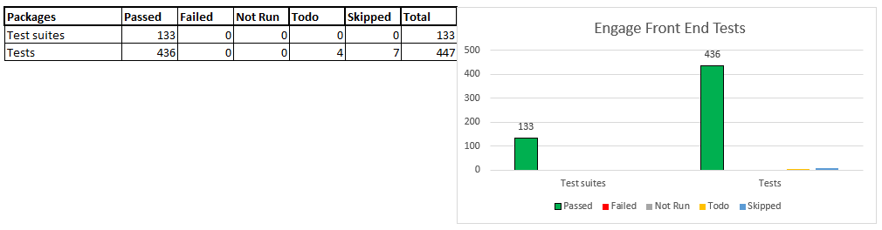Backend test from cms
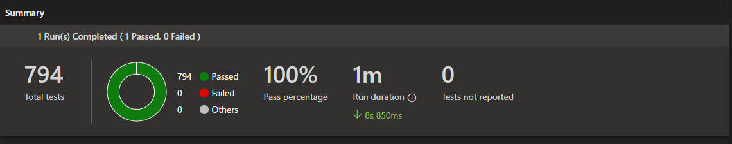
Backend API tests
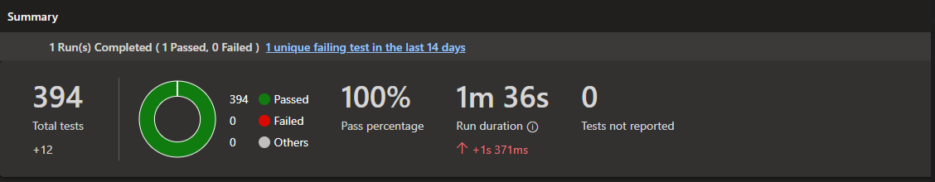

Tests Summary
Key | Summary | Issue Assignee | Requirements | Test Executions | Latest Status
EN-369 | Test The "close window"-cross in template library is slightly to big. | Linsha Pathanamkurussi | EN-329 | EN-370 | PASSED

EN-371 | Test Closing X is missing | Linsha Pathanamkurussi | EN-368 | EN-372 | PASSED

EN-375 | Test Create player API requires networkGroupId | Sami-Pekka Laine | EN-294 | EN-376 | PASSED

EN-377 | Test Users are able to click edit on playlists that do not belong to their workspace | Linsha Pathanamkurussi | EN-361 | EN-378 | PASSED

EN-379 | Test Playlist status shown as "Disabled" in players view | Sami-Pekka Laine | EN-340 | EN-380  EN-434 | PASSED

EN-381 | Test Last modified playlist on dashboard not showing | Linsha Pathanamkurussi | EN-359 | EN-383 | PASSED

EN-390 | Test Add an endpoint to create media without triggering Transcoder-job | Sami-Pekka Laine | EN-58 | EN-391  EN-438 | PASSED

EN-393 | Test Provide SAS token to upload to Azure Storage | Sami-Pekka Laine | EN-59 | EN-394  EN-439 | PASSED

EN-395 | Test Add an endpoint to set thumb-data after uploading media to Azure storage | Sami-Pekka Laine | EN-60 | EN-396  EN-440 | PASSED

EN-408 | Test Two endpoints having same path | Sami-Pekka Laine | EN-373 | EN-409  EN-433 | PASSED

EN-407 | Test Duration changes on images inside of a playlist is not persisting | Linsha Pathanamkurussi | EN-387 | EN-412 | PASSED

EN-415 | Test Add setting to the CMS/backend to change setting for WebOS | Sami-Pekka Laine | EN-115 | EN-416 | PASSED

EN-418 | Test Create endpoint to schedule multiple media | Sami-Pekka Laine | EN-342 | EN-419  EN-437 | PASSED

EN-422 | Test Endpoint to apply media defaultschedule to selected playlists/campaigns. When no playlists are selected it will be applied to all playlists/campaigns | Unassigned | EN-223 | EN-428  EN-441 | PASSED

EN-420 | Test Develop a new update endpoint for updating default schedules for media item | Sami-Pekka Laine | EN-296 | EN-429  EN-436 | PASSED

EN-421 | Test Develop a new Get endpoint for fetching default schedules for media item | Sami-Pekka Laine | EN-297 | EN-430  EN-435 | PASSED

EN-431 | Test Move-sidebar should close after the Move has been done. | Sami-Pekka Laine | EN-345 | EN-432 | PASSED

EN-446 | Test As a user I want to schedule multiple medias from library to one or more playlist | Sami-Pekka Laine | EN-19  EN-22  EN-20  EN-222 | EN-447  EN-448 | PASSED

